**FARMER ASSISTANT PORTAL**

|  |  |
| --- | --- |
| **CONTENT** | **PAGE NO** |
| **Abstract** |  |
| **1.INTRODUCTION** |  |
| 1.1 Motivation |  |
| 1.2 Problem Statement |  |
| 1.3 Objective of the Project |  |
| 1.4 Scope |  |
| 1.5 Project Introduction |  |
| **2.LTERATURE SURVEY** |  |
| 2.1 Related Work |  |
| **3. SYSTEM ANALYSIS** |  |
| 3.1 Existing System |  |
| 3.2 Disadvantages |  |
| 3.3 Proposed System |  |
| 3.4 Advantages |  |
| 3.5 work Flow of Proposed system |  |
| **4. REQUIREMENT ANALYSIS** |  |
| 4.1Function and non-functional requirements |  |
| 4.2 Hardware Requirements |  |
| 4.3 Software Requirements |  |
| 4.4 Architecture |  |
| **5. SYSTEM DESIGN** |  |
| 5.1 Introduction of Input design |  |
| 5.2 UML Diagram(class, use case, sequence, collaborative, deployment, |  |
| 5.3 Data Flow Diagram |  |
| **6. IMPLEMENTATION AND RESULTS** |  |
| 6.1 Modules |  |
| 6.2 Output Screens |  |
| 1. **JAVA ENVIRONMENT** |  |
| 7.1 Software Installation |  |
| 7.2 About Java Language |  |
| 1. **SYSTEM STUDY AND TESTING** |  |
| 8.1 Feasibility study |  |
| 8.2 Types of test |  |
| **9. CONCLUSION** |  |
| **10. FUTURE ENHANCEMENT** |  |
| **11. REFERENCES** |  |

**ABSTRACT**

The amazing developments in science and technology have raised the bar for human living standards. Without these improvements, the entire planet will be physically congested. Compared to other projects now in existence, this project is innovative in that it simplifies the process of getting farming. Java has been used to implement this project. The project's goal is to create an application software to lessen the human labour involved in keeping track of the farming of different crops consumed by people and getting farming on different ways based on

seasonal wise. The fast changing environment, including difficult market conditions and a high exposure to financial risks are major reasons for changing production policy. Farm Management Systems appear to be a powerful tool to deal with the new conditions. However, farmers still rely more on their intuition than on proper management tools, when it comes to running a farm business. Many farmers do not use Farm management for various reasons, like lack of knowledge and the complexity of many available farm managements. In particular for small to medium-sized farms and for multifunctional farms appropriate farm management hardly exist.

**Keywords:** Farming, Crops, Products , Admin, Customer, Orders etc.

1. **INTRODUCTION**

**1.1 Motivation:**

The motivation for a Farmer Assistant Portal lies in improving the well-being and prosperity of farmers by providing them with resources, information, and opportunities that can positively impact their agricultural practices and quality of life.

**1.2 Problem Statement:**

The successful implementation of the Farmer Assistant Portal will empower farmers with knowledge, resources, and connections necessary to thrive in their agricultural pursuits. This digital solution has the potential to elevate agricultural productivity, boost rural economies, foster sustainable practices, and enhance the overall quality of life for farmers and their communities.

**1.3 Objective of the Project:**

The objective of the Farmer Assistant Portal project is to empower farmers with the knowledge and resources they need to make informed decisions, implement modern practices, and thrive in their agricultural pursuits, thereby creating a positive impact on their lives and the agricultural sector as a whole.

**1.4 Scope:**

The scope of the Farmer Assistant Portal is vast, aiming to provide a holistic solution that empowers farmers with the tools, knowledge, and connections they need to enhance their agricultural practices, increase productivity, and improve their livelihoods. The specific scope can be tailored based on the target audience, geographical region, and technological capabilities.

**1.5 Project Introduction:**

Introduction to the "Farmer assistant portal" Project:

An innovative and empowering platform designed to revolutionize the way farmers interact with technology and information. In today's rapidly evolving world, where agriculture plays a pivotal role in sustaining global populations, our Farmer Assistant Portal emerges as a beacon of support for farmers worldwide.

In this interconnected era, harnessing the power of technology is crucial for optimizing agricultural processes, increasing productivity, and ensuring sustainable practices. The Farmer Assistant Portal Project is a visionary initiative aimed at bridging the gap between traditional farming practices and cutting-edge technology. By providing farmers with a comprehensive digital toolkit, this platform strives to enhance efficiency, knowledge-sharing, and ultimately, the livelihoods of those who feed the world.

Our Farmer Assistant Portal is more than just a tool; it's a dynamic ecosystem. It seamlessly integrates real-time weather data, market trends, crop-specific insights, and best agricultural practices, all tailored to individual farming contexts. Whether a seasoned farmer or a novice, this portal empowers users with actionable information that enables informed decision-making and promotes resilient farming methods.

But this project goes beyond data dissemination. It's about community building and collaboration. The Farmer Assistant Portal fosters connections between farmers, agri-experts, and researchers, creating a space for dialogue, learning, and collective problem-solving. Through discussion forums, webinars, and interactive workshops, the portal becomes a hub of knowledge exchange, where experiences and wisdom are shared across borders and generations.

As we embark on this transformative journey, we invite you to explore the Farmer Assistant Portal – an embodiment of our commitment to sustainable agriculture, technological advancement, and the well-being of farming communities. Together, we sow the seeds of progress, growth, and prosperity, cultivating a brighter future for farmers and our planet alike.

1. **LITERATURE SURVEY**

**2.1 Related Work:**

International Journal of Advanced Science and Technology

Vol. 29, No. 6, (2020), pp. 4783 - 4786

**[1] Manav Singhal, Kshitij Verma, Anupam Shukla, “Krishi Ville-Android based solution for Indian agriculture”. 2011 Fifth IEEE International Conference on Advanced Telecommunication Systems and Networks (ANTS), 18-21 Dec. 2011, Bangalore, India.**

Information and Communication Technology (ICT) in agriculture is an emerging field focusing on the enhancement of agricultural and rural development in India. It involves innovative applications using ICT in the rural domain. The advancement of ICT can be utilized for providing accurate and timely relevant information and services to the farmers, thereby facilitating an environment for remunerative agriculture. This paper describes a mobile based application for farmers which would help them in their farming activities. We propose an android based mobile application — Krishi Ville which would take care of the updates of the different agricultural commodities, weather forecast updates, agricultural news updates. The application has been designed taking indian farming in consideration.

**[2] Soumalya Ghosh, A. B. Garg, Sayan Sarcar, P.S.V.S Sridhar, Ojasvi Maleyvar, and Raveesh kapoor, “Krishi-Bharati: An Interface for Indian Farmer”, Proceedings of the 2014 IEEE Students' Technology Symposium, 28 Feb.-2 March 2014, Kharagpur, India.**

Information and Communication Technologies (ICTs) have made our life easy. ICTs are playing valuable roles in a variety of technical fields such as education, banking, health, E-commerce and many more. ICSs can also be used for farmers to help them to get more production and profit. This paper describes a web-based system-"Krishi-Portal" which will assist farmers to get information about various crops, diseases on crops, crop's rates, government schemes for farmers and weather forecasting. The system is also a good platform for selling farmer's production and buying material from vendors, which is necessary for farming. Farmers can also buy or sell new or old agricultural machinery that are used in farms like cultivators, Disc Harrow etc. This system is specifically useful for farmers but other business sectors will definitely get benefit of it; those are Agricultural agencies (such as Tractor sellers), Hotels (by getting raw materials-vegetables, milk etc.), Fertilizer sellers.

**[3] Shankar M. Patil, Monika Jadhav, Vishakha Jagtap, “Android Application for Farmers”, International Research Journal of Engineering and Technology, volume 6, issue 4, 2019, 4200-4202p.**

Agriculture is a top priority in India but today the people involved in agriculture are of a lower class and face a lot of trouble in their day to day life due to extreme poverty. Due to lack of awareness of modern technology or advanced techniques it leads to Farm poverty. The purpose of this project is to help farmers to solve their problems in an instant of time. Smallholder farmers who well educated, most of the agricultural products are faced a wide array of problems, including access to sufficient information, services. Middleman's role in marketing the farm product is necessary to remove in order to provide direct sales and good value to farmers and customers. In this application farmer can book vehicles regarding farm. This application helps farmers ensure maximum profitability by using direct farmer to customer and language communication with farmers. This optimization site allows for better communication between the farmer and the customer. Through this application we can guarantee farmers to make selling decisions most advantageously.

**[4] Shital Chaudhari, Vaishnavi Mhatre, Pooja Patil, Sandeep Chavan, “Smart Farm Application: A Modern Farming Technique Using Android Application”, International Research Journal of Engineering and Technology, volume 5, issue 2, 2018, 318-320p.**

Today, everyone is familiar with mobile devices. Also including the farmers and countryside people. Mobile plays vital role in daily life of farmers as well as other people. The farmers, who were dependent on clouds for rain, now are looking into the Cloud Computing for their solutions towards cultivation of superior crops in today’s modern agricultural world. The traditional methods used by the farmers, peculiarly in India, are very slow and understandable. Although most people can see the benefits of using more precious approach to manage crops with additional information, the tools provided for farming and other information technologies have not yet moved into mainstream agriculture management

**[5] Arpit Narechania “KisanVikas – Android Based ICT Solution in Indian Agriculture to Assist Farmers”. Proceeding of the 7th International Conference on Information and Communication Technologies in Agriculture, Food and Environment (HAICTA 2015), Kavala, Greece, 17-20 September, 2015.**

Agriculture accounts for ~15% of the Gross Domestic Product (GDP) of India but employs close to 50% of the working population. Average yield in India is quite low compared to other countries. Advances in Information and Communication Technology (ICT) and the government initiatives in e-governance are only promoting e-agriculture in India. This can not only improve the condition of Indian agriculture but also the life and working conditions of the farmers. This paper proposes KisanVikas (Farmer Development), a mobile application, using ICT and promoting e-governance by provide continuous information pertaining to agriculture- weather forecast, crop prices, news, government helplines, and an inventory database manager. The mobile application also connects to an Arduino based wireless sensor network (WSN) comprising soil moisture, pH and temperature sensors to control water pumps for watering small fields, irrigation over the Global System for Mobile communication (GSM) and Bluetooth networks

**[6] Shaik. N. Meera, Anita Jhamtani, D.U.M. Rao (2004). Information and Communication Technology in Agricultural Development: A Comparative Analysis of Three Projects from India [Online] [April 2020].**

The study points out that low coverage, low operational performance, low participation of volunteer farmers, low awareness of farmers, low access of farmers to institutional credit, continuous banks’ failure in achieving the target of priority sector in common and agriculture credit in particular, shrinking the banking facilities in rural areas, re-emergence of unauthorized source of credit in rural areas, low education of farmers, non cooperation of bankers towards farmers, problems of design and implementation of the NAIS, problems of obtaining accurate and timely price data from local markets, the model of measurement of agriculture loss by natural hazards which is not appropriate to all farmers are the common weakness of the National Agriculture Insurance Scheme (NAIS). The agriculture sector of India—the main employment provider and the backbone of Indian economy, is affected most by recurring natural hazards due to climate changes, and requires the most care and protection against all sort of uncertainties, hence, NAIS can prove itself as the best protector (Ram Baan) in this context.

**3. SYSTEM ANALYSIS**

**3.1 Existing System**

People now a days use a manual process for buying products and required things, due to some reasons. They have got used to the manual process and they can go along with it even though there are concerns associated with it. They are reluctant to change their current process since it will be an extra effort. The farm management for a new solution. However, the customers face immense problems with the current procedure of using this manual process to getting formation items.

* 1. **Disadvantages**

**1.** **Not User Friendly:** The existing system is not user friendly because the retrieval of data is very slow and data is not maintained efficiently.

**2.** **Difficulty in report generating:** We can’t able see the all the tourism places information. And the people not get at the time of searching for tour.

**3.** **Manual control:** people may be get some wrong information from diffrent resources .

**4.** **Time consuming:** Every work is done manually so we cannot get the information in the middle of the tour or as per the requirement because it is very time consuming.

**3.3 Proposed System**

To overcome the problem with an existing system, we are implementing an application called farm management system using java. Using this application customers can get all the products information via through his own accounts. After that customer can able to add products to the cart and buy the required things through online.

**3.4 Advantages**

**1.** **User Friendly:** - The proposed system is user friendly because the retrieval and storing of data is fast and data is maintained efficiently. Moreover the graphical user interface is provided in the proposed system, which provides user to deal with the system very easily.

**2.** **Reports are easily generated:** reports can be easily generated in the proposed system so user can get information at anytime

**3. Very less work:** The proposed system requires very less work. All the data is fetched into the computer immediately and reports can be generated through computers. Moreover work becomes very easy because there is no need to keep data on papers.

**4. Computer operator control:** Computer operator control will be there so no chance of errors. Moreover storing and retrieving of information is easy. So work can be done speedily and in time.

**3.5 work Flow of Proposed system**

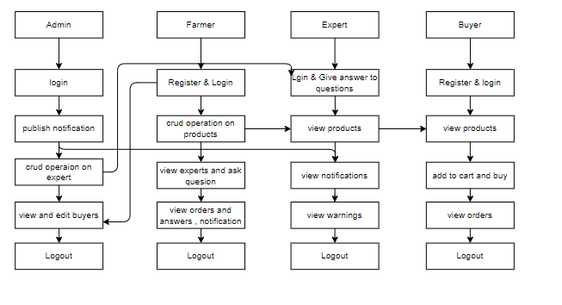

**4. REQUIREMENT ANALYSIS**

**4.1 Functional and non-functional requirements**

Requirement’s analysis is very critical process that enables the success of a system or software project to be assessed. Requirements are generally split into two types: Functional and non-functional requirements.

**Functional Requirements**: These are the requirements that the end user specifically demands as basic facilities that the system should offer. All these functionalities need to be necessarily incorporated into the system as a part of the contract. These are represented or stated in the form of input to be given to the system, the operation performed and the output expected. They are basically the requirements stated by the user which one can see directly in the final product, unlike the non-functional requirements.

Examples of functional requirements:

1. Authentication of user whenever he/she logs into the system
2. System shutdown in case of a cyber-attack
3. A verification email is sent to user whenever he/she register for the first time on some software system.

**Non-functional requirements**: These are basically the quality constraints that the system must satisfy according to the project contract. The priority or extent to which these factors are implemented varies from one project to other. They are also called non-behavioral requirements.  
They basically deal with issues like:

* Portability
* Security
* Maintainability
* Reliability
* Scalability
* Performance
* Reusability
* Flexibility

Examples of non-functional requirements:

1. Emails should be sent with a latency of no greater than 12 hours from such an activity.
2. The processing of each request should be done within 10 seconds
3. The site should load in 3 seconds whenever of simultaneous users are > 10000
   1. **Hardware Requirements**

# Processor : - I3/Intel Processor

# Operating System : Windows 7/8/10

# Server side Script : React Js

# Programming Language : java

# IDE/Workbench : Intellij IDEA

* 1. **Software Requirements:**

Technology : java

Server Deployment : tomcat Server

Database : MySQL

**Architecture:**

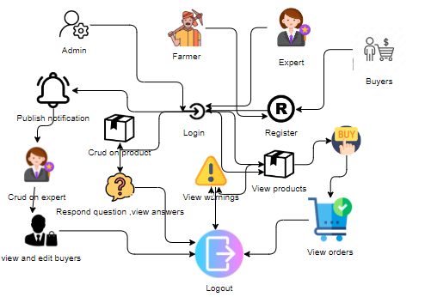

**5. SYSTEM DESIGN**

**5.1 Introduction of Input Design:**

In an information system, input is the raw data that is processed to produce output. During the input design, the developers must consider the input devices such as PC, MICR, OMR, etc.

Therefore, the quality of system input determines the quality of system output. Well-designed input forms and screens have following properties −

* It should serve specific purpose effectively such as storing, recording, and retrieving the information.
* It ensures proper completion with accuracy.
* It should be easy to fill and straightforward.
* It should focus on user’s attention, consistency, and simplicity.
* All these objectives are obtained using the knowledge of basic design principles regarding −
  + What are the inputs needed for the system?
  + How end users respond to different elements of forms and screens.

### **Objectives for Input Design:**

The objectives of input design are −

* To design data entry and input procedures
* To reduce input volume
* To design source documents for data capture or devise other data capture methods
* To design input data records, data entry screens, user interface screens, etc.
* To use validation checks and develop effective input controls.

**Output Design:**

The design of output is the most important task of any system. During output design, developers identify the type of outputs needed, and consider the necessary output controls and prototype report layouts.

### Objectives of Output Design:

The objectives of input design are:

* To develop output design that serves the intended purpose and eliminates the production of unwanted output.
* To develop the output design that meets the end user’s requirements.
* To deliver the appropriate quantity of output.
* To form the output in appropriate format and direct it to the right person.
* To make the output available on time for making good decisions.

**5.2 UML Diagrams:**

**5.2.1 Use Case Diagram:**

A use case diagram in the Unified Modeling Language (UML) is a type of behavioral diagram defined by and created from a Use-case analysis. Its purpose is to present a graphical overview of the functionality provided by a system in terms of actors, their goals (represented as use cases), and any dependencies between those use cases. The main purpose of a use case diagram is to show what system functions are performed for which actor. Roles of the actors in the system can depicted.

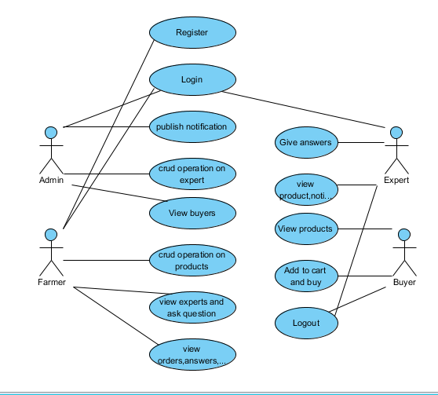

**5.2.2 Class Diagram:**

In software engineering, a class diagram in the Unified Modelling Language (UML) is a type of static structure diagram that describes the structure of a system by showing the system's classes, their attributes, operations (or methods), and the relationships among the classes. It explains which class contains information.

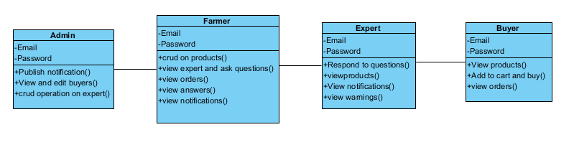

**5.2.3 Sequence Diagram:**

A sequence diagram in Unified Modelling Language (UML) is a kind of interaction diagram that shows how processes operate with one another and in what order. It is a construct of a Message sequence Chart. Sequence diagrams are sometimes called event diagrams, event scenarios, and

Event timings.

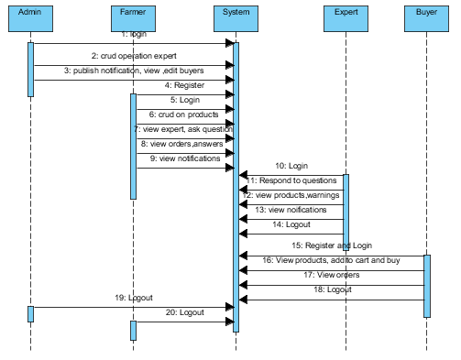

**5.2.4 Collaboration Diagram:**

In collaboration diagram the method call sequence is indicated by some numbering technique as shown below. The number indicates how the methods are called one after another. We have taken the same order management system to describe the collaboration diagram. The method calls are similar to that of a sequence diagram. But the difference is that the sequence diagram does not describe the object organization whereas the collaboration diagram shows the object organization.

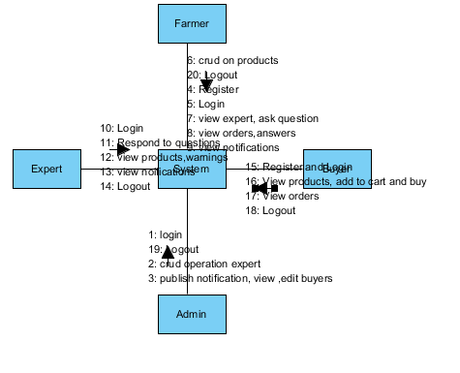

**5.2.5 Deployment Diagram**

Deployment diagram represents the deployment view of a system. It is related to the component diagram. Because the components are deployed using the deployment diagrams. A deployment diagram consists of nodes. Nodes are nothing but physical hardware’s used to deploy the application.

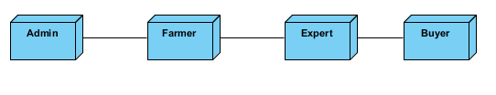

**5.2.6 Activity Diagram:**

Activity diagrams are graphical representations of workflows of stepwise activities and actions with support for choice, iteration and concurrency. In the Unified Modelling Language, activity diagrams can be used to describe the business and operational step-by-step workflows of components in a system. An activity diagram shows the overall flow of control.

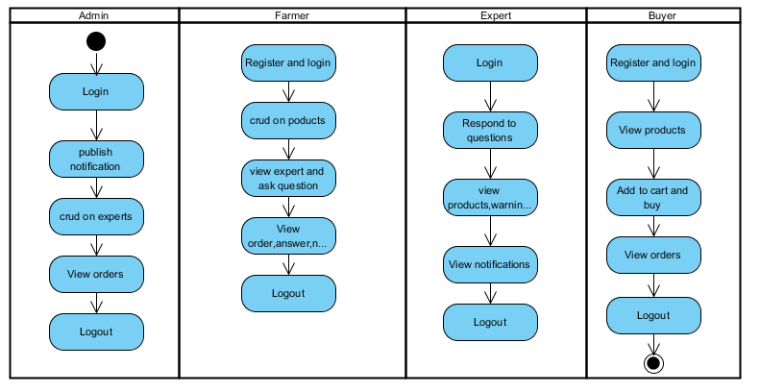

**5.2.7 Component Diagram**:

A component diagram, also known as a UML component diagram, describes the organization and wiring of the physical **c**omponents in a system. Component diagrams are often drawn to help model implementation details and double-check that every aspect of the system's required functions is covered by planned development.

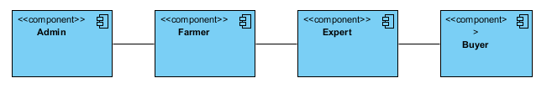

**5.2.8 ER Diagram:**

An Entity–relationship model (ER model) describes the structure of a database with the help of a diagram, which is known as Entity Relationship Diagram (ER Diagram). An ER model is a design or blueprint of a database that can later be implemented as a database. The main components of E-R model are: entity set and relationship set.

An ER diagram shows the relationship among entity sets. An entity set is a group of similar entities and these entities can have attributes. In terms of DBMS, an entity is a table or attribute of a table in database, so by showing relationship among tables and their attributes, ER diagram shows the complete logical structure of a database. Let’s have a look at a simple ER diagram to understand this concept.

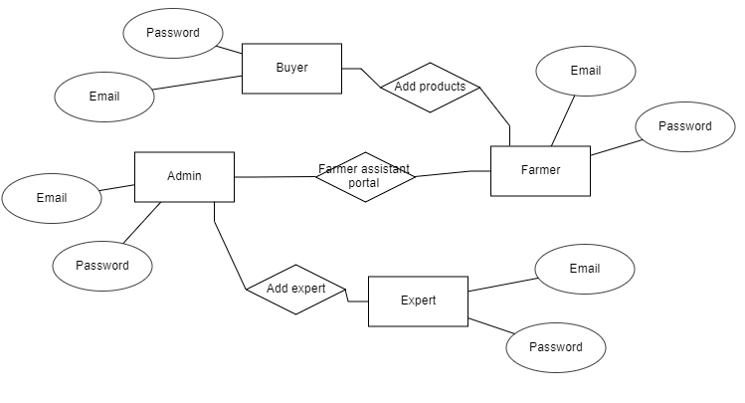

**5.3 DFD Diagram:**

A Data Flow Diagram (DFD) is a traditional way to visualize the information flows within a system. A neat and clear DFD can depict a good amount of the system requirements graphically. It can be manual, automated, or a combination of both. It shows how information enters and leaves the system, what changes the information and where information is stored. The purpose of a DFD is to show the scope and boundaries of a system as a whole. It may be used as a communications tool between a systems analyst and any person who plays a part in the system that acts as the starting point for redesigning a system.

**Context level:**

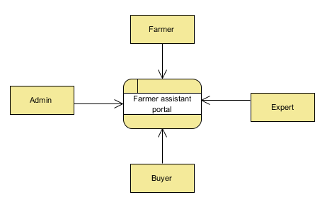

**Level 1 Diagram:**

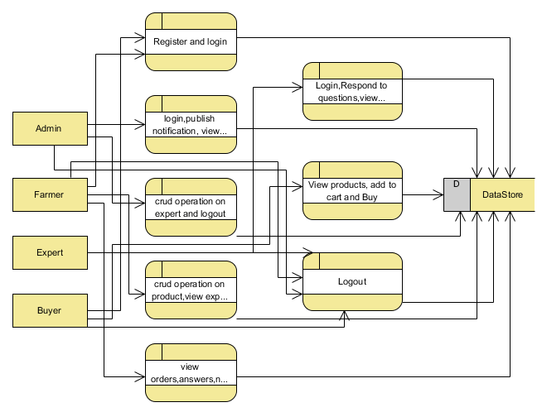

**Level 2 Diagram:**

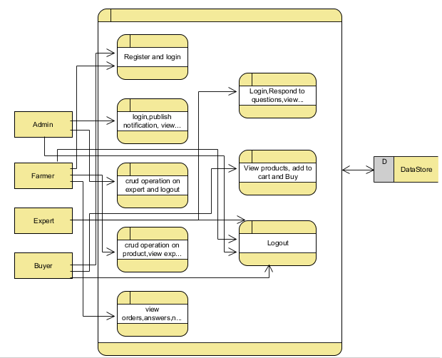

**IMPLEMENTATION AND RESULTS**

**6.1 Modules:**

**Admin:**

Operation-**Login:** Admin will login into the application by entering the valid details like (username and password).

**Publish Notification:** Admin can publish the notifications.

**CRUD Operations on Expert:** Admin can manage expert like add, read, update, delete.

**View Buyers:** Admin can view all the buyers and also edit

**Farmer:**

Operation-**Login:** Farmer will login into the application by entering the valid details like (username and password).

**View Profile:** Farmer can view and update his profile.

**CRUD Operations on Product:** Farmer can manage product like add, read, update, delete.

**View Expert:** Farmer can view expert and ask questions.

**View Orders:** Farmer can view all orders.

**View Question & Answers:** Farmer can view all questions and answers.

**View Notification:** Farmer can view all notifications.

**Expert:**

**View Question&&Answers:** Expert can view questions and answers and respond to questions.

**View Products:** Expert can view all the products.

**View Notifications:** Expert can view all the notifications.

**View Warnings:** Expert can view all the warnings.

**Buyer:**

**View Products:** Buyer can view all the products.

**Add to cart:** Buyer can add the products to cart and buy.

**View Orders:** Buyer can view all the orders.

**6.2 Results:**

**Home Page :**  This is the home page.



**Login Page :**  This is the login page .

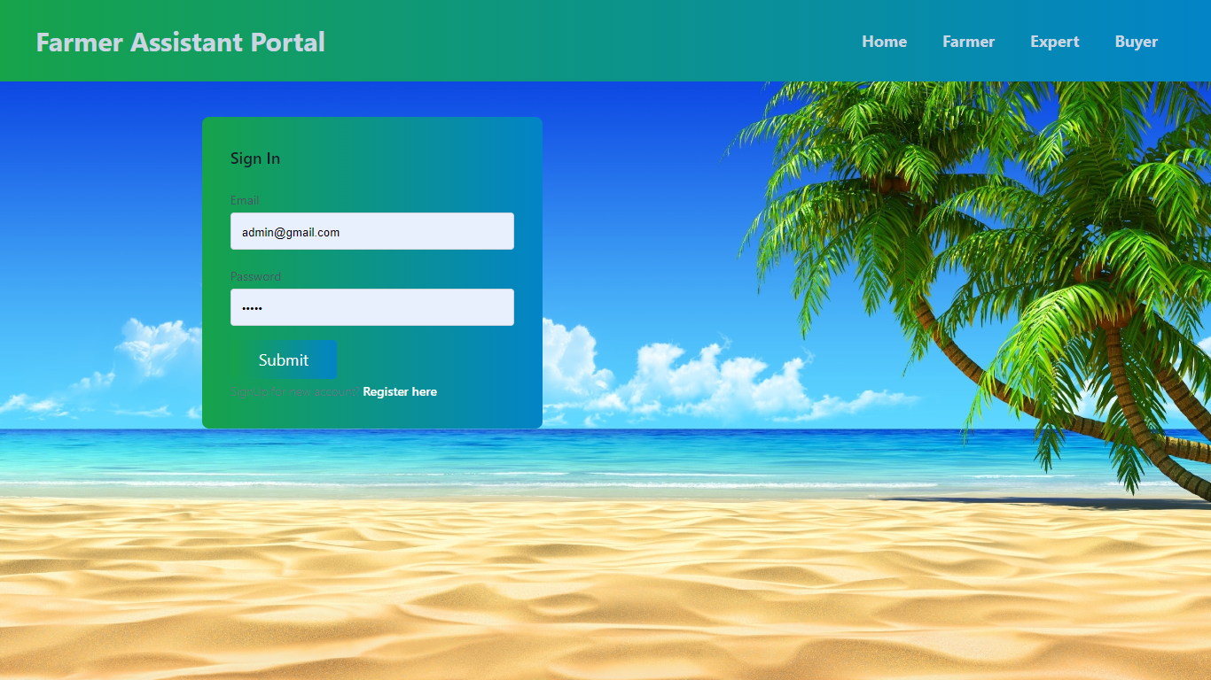

**Home Page :**  This is the admin home page.

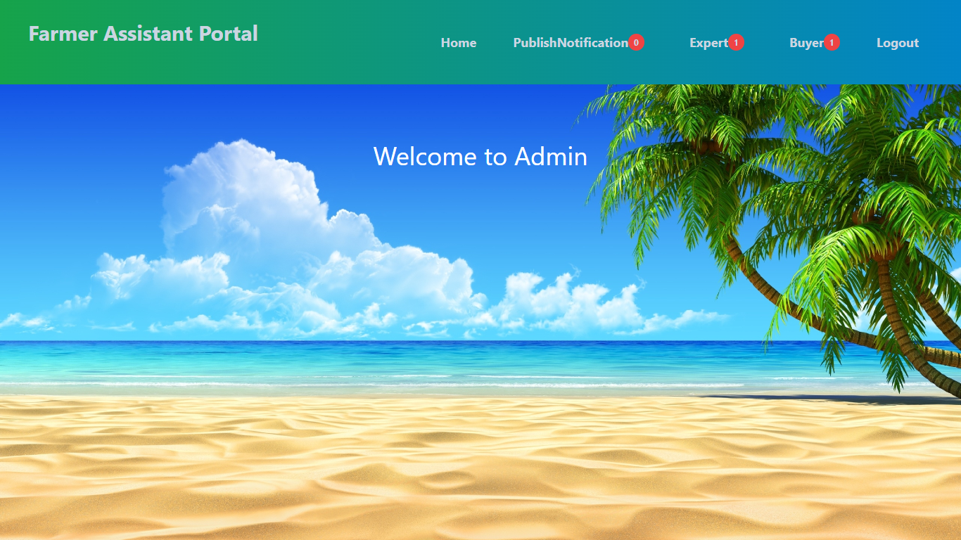

**Add notification :**  This is the page for add notification.

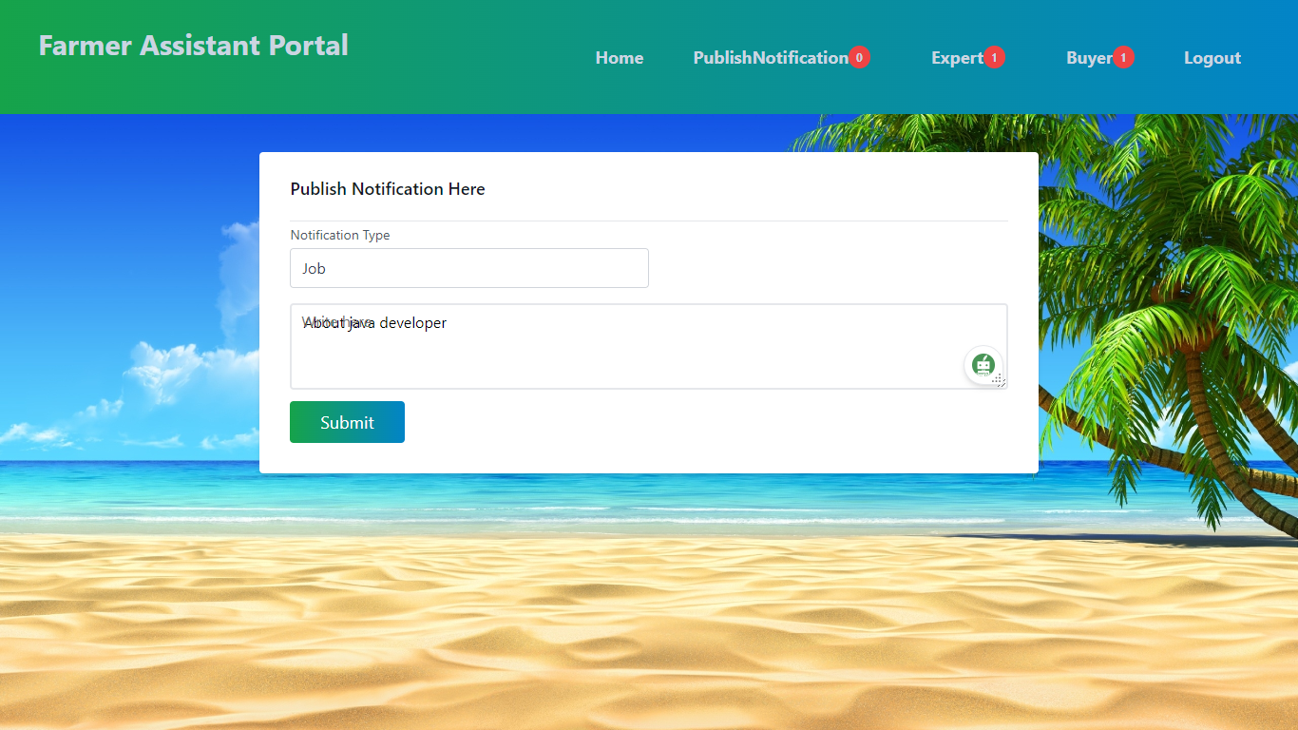

**CRUD on Experts:** Admin can manage experts.

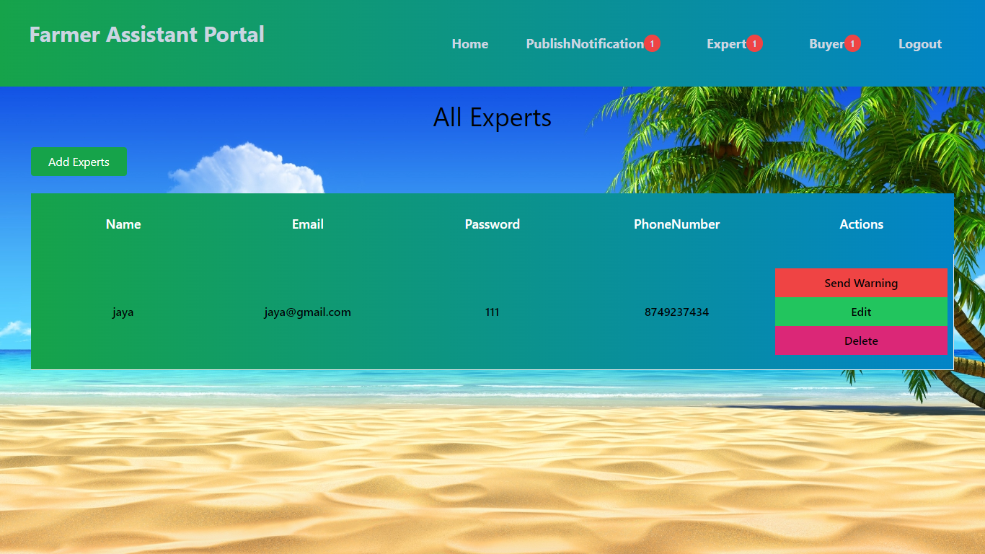

**Add warning:** Admin giving warning to expert.

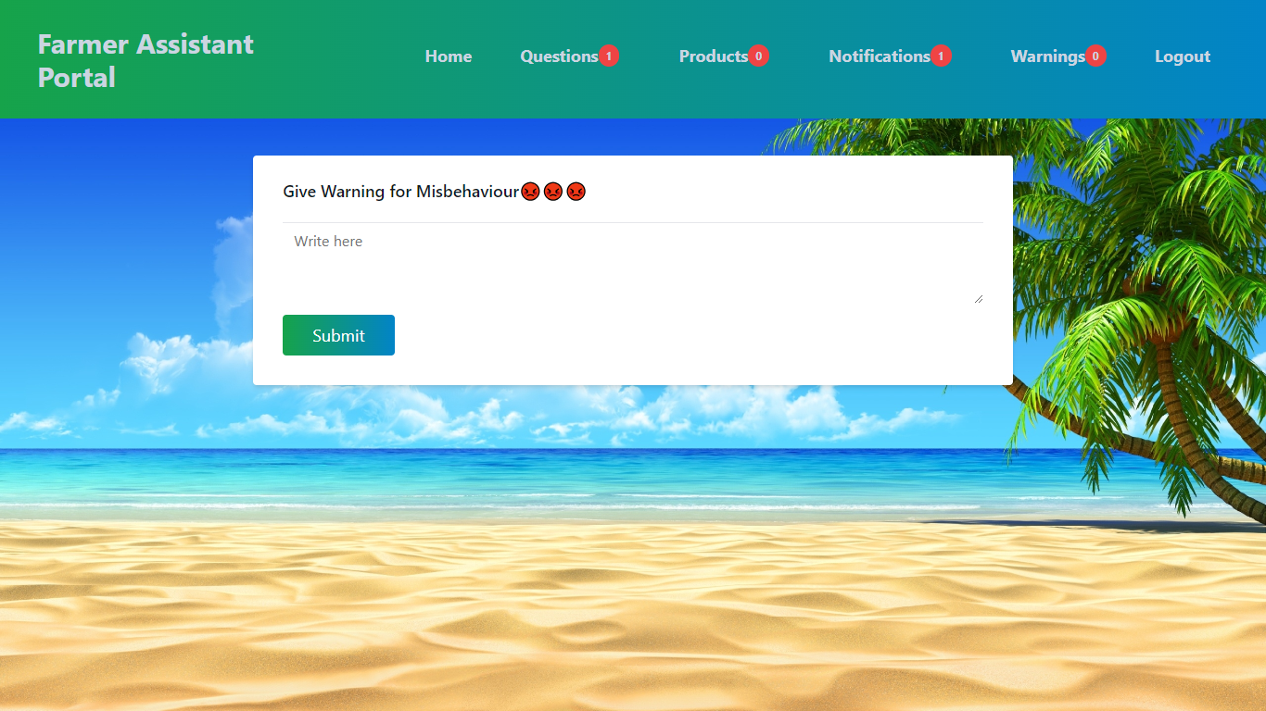

**View buyers:** Admin view all buyers.

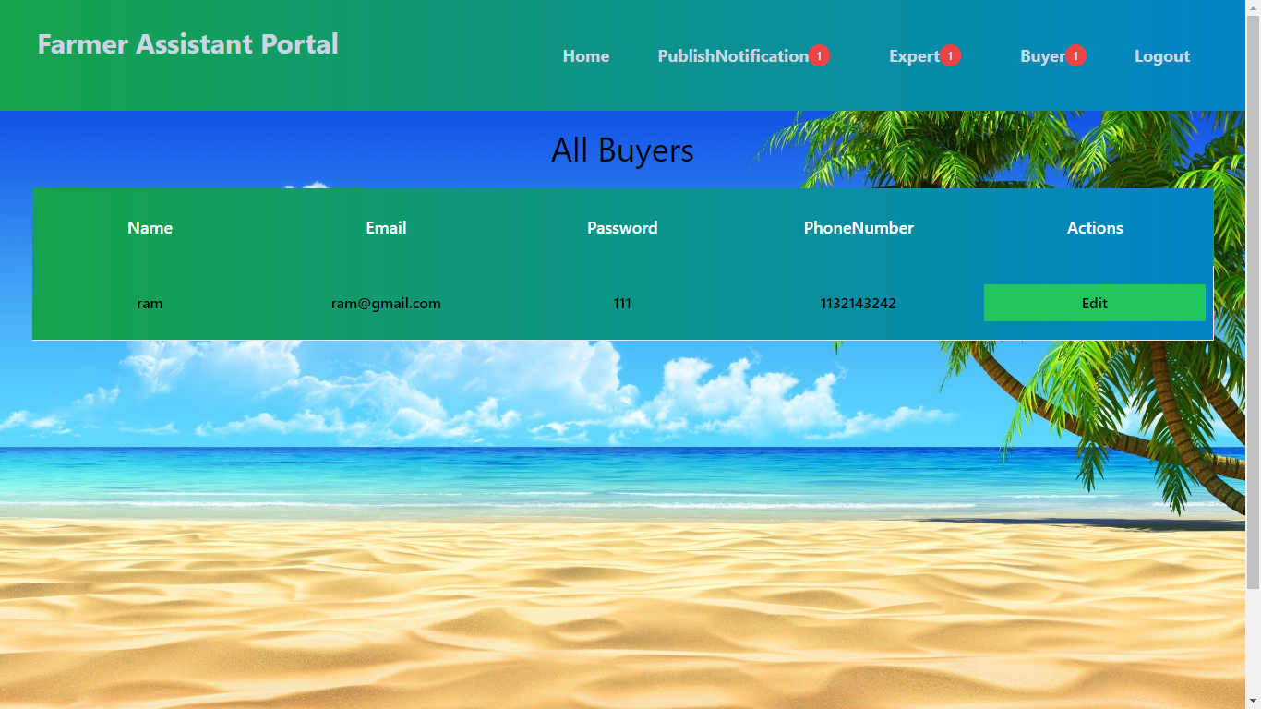

**Register page:** This is the register page.

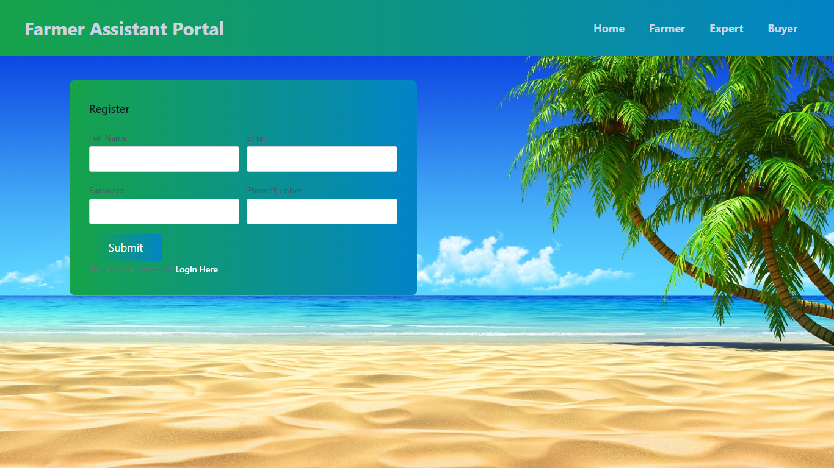

**View products:** Farmer can manage products.

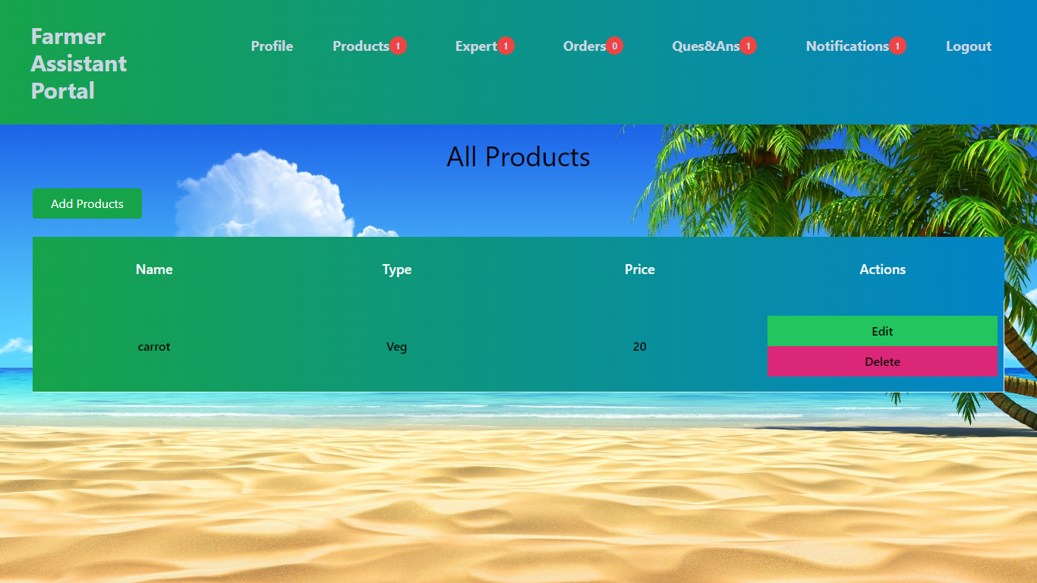

**View experts:** Farmer can view all experts

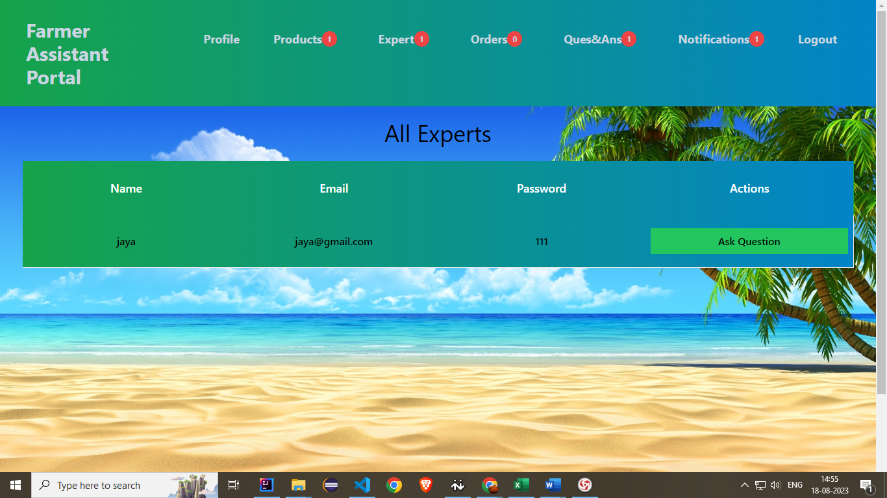

**View orders:** Farmer view all orders.

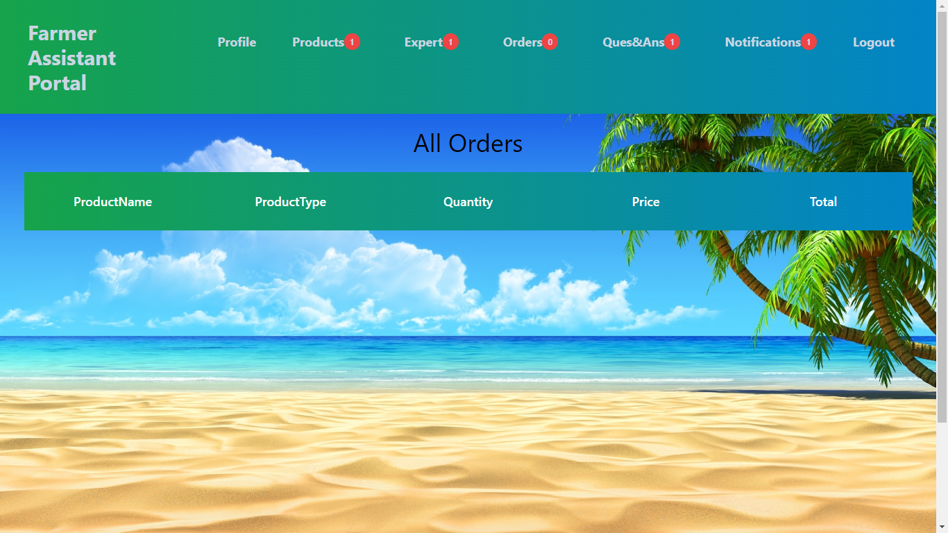

**View question& answers:** Farmer view all question and answers.

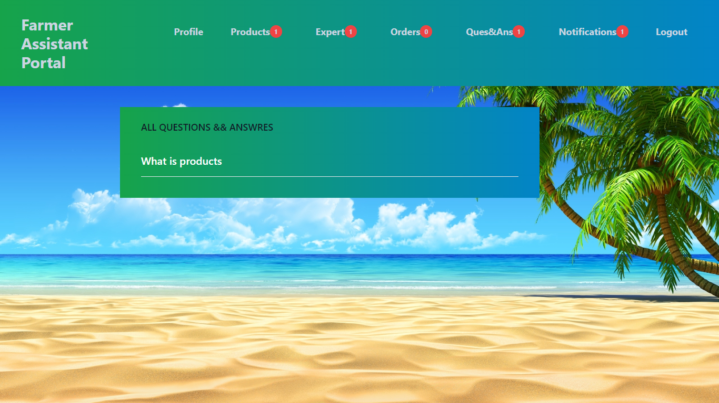

**View notifications:** Farmer view all notifications.

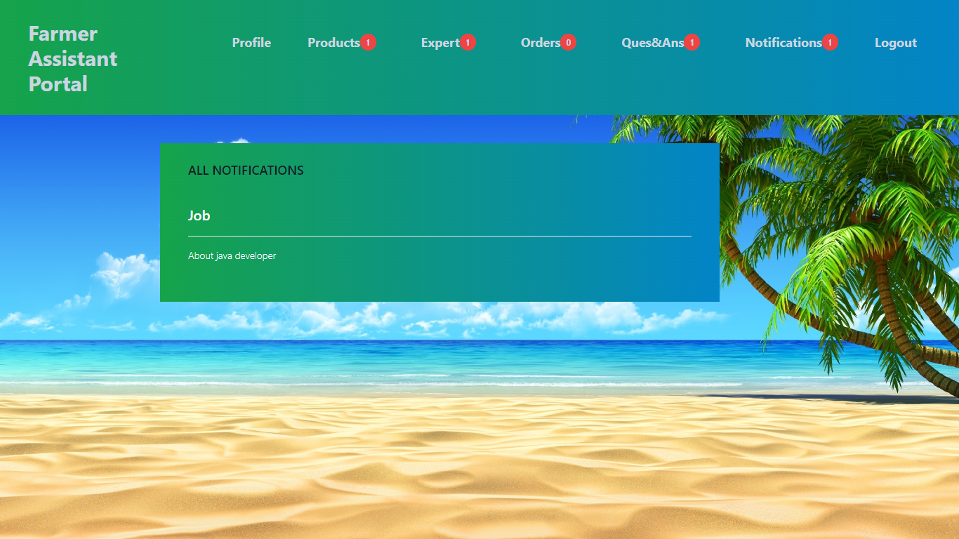

**Expert home page:** This is the expert home page.

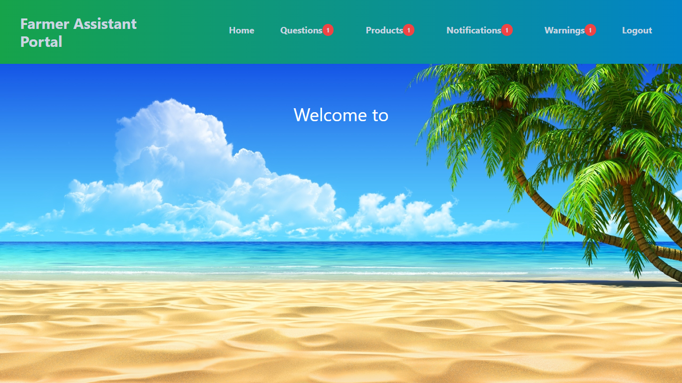

**View questions:** Expert view all questions and respond.

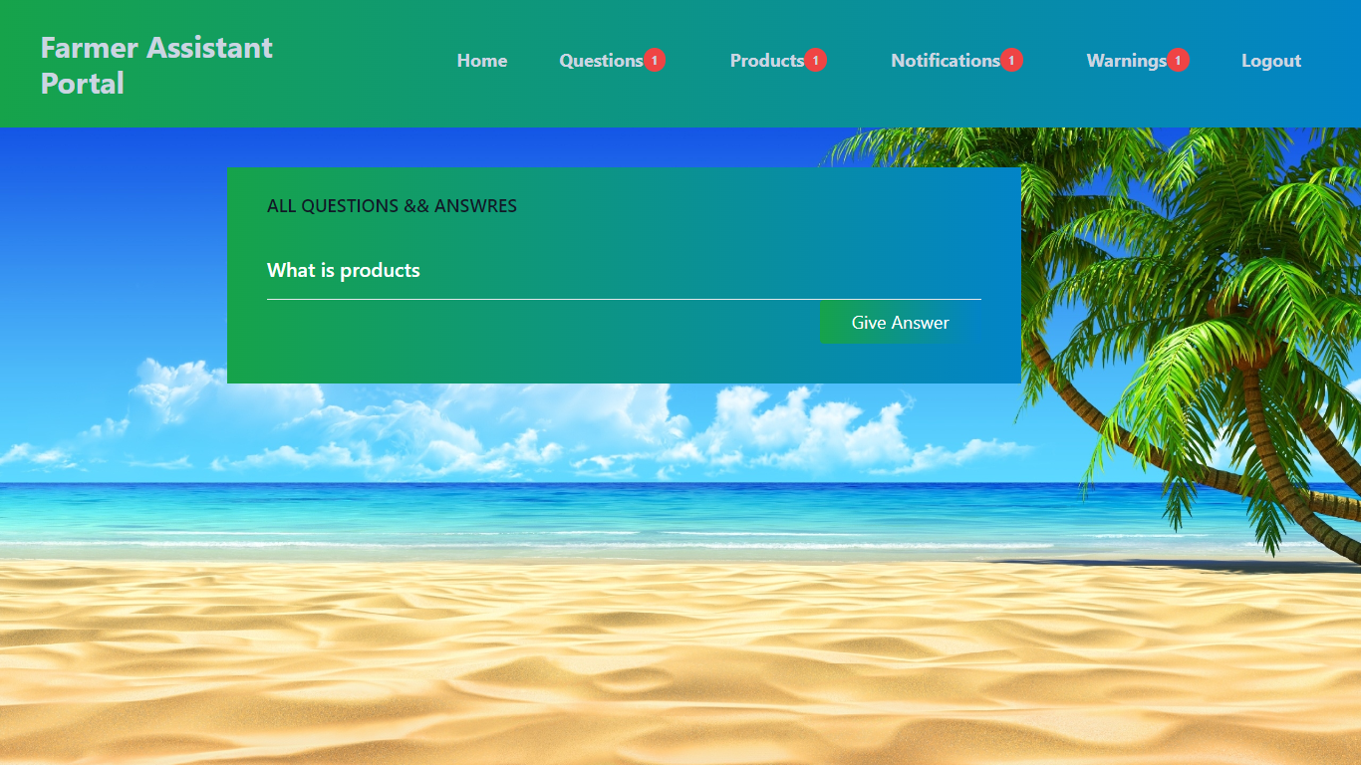

**View warnings:** Expert view all warnings.

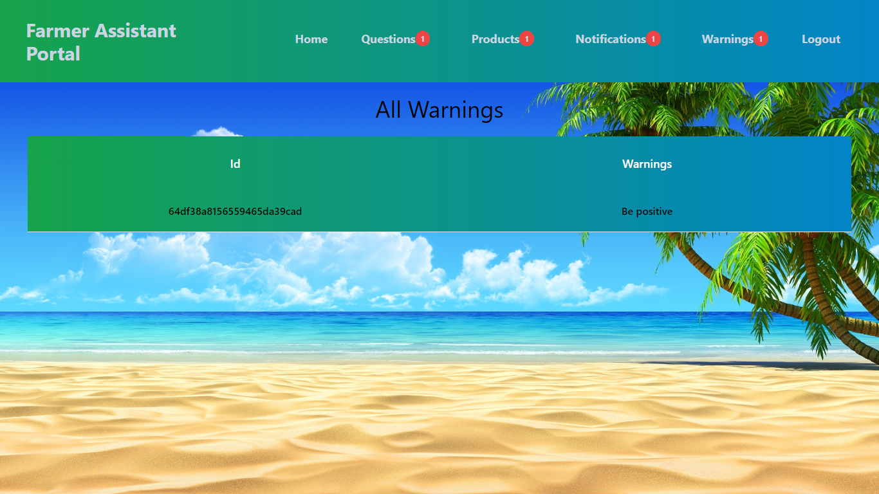

**Buyer home page:** This is the buyer home page.

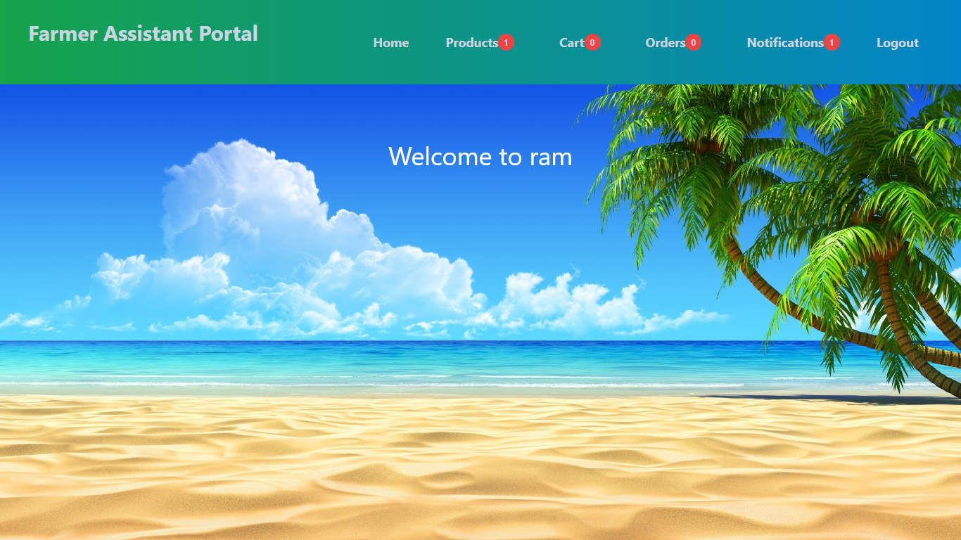

**View products:** Buyer can view all products and he can add to cart

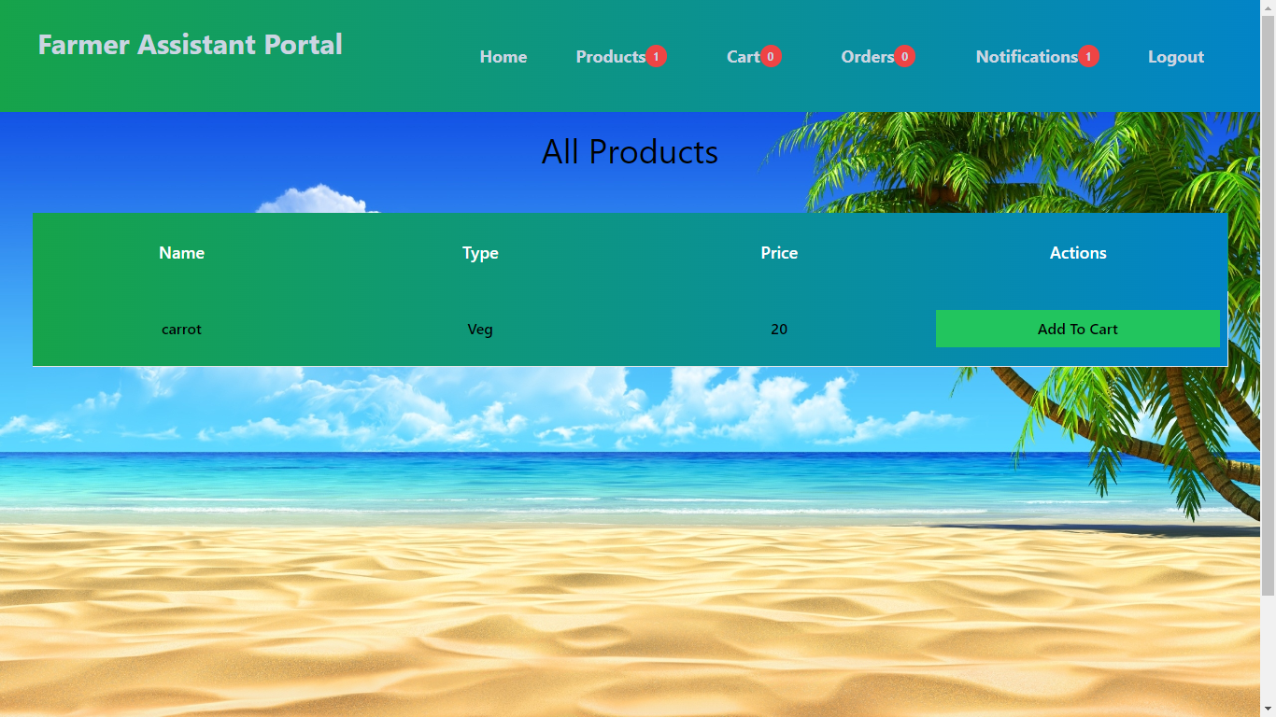

**View cart:** Buyer view his cart

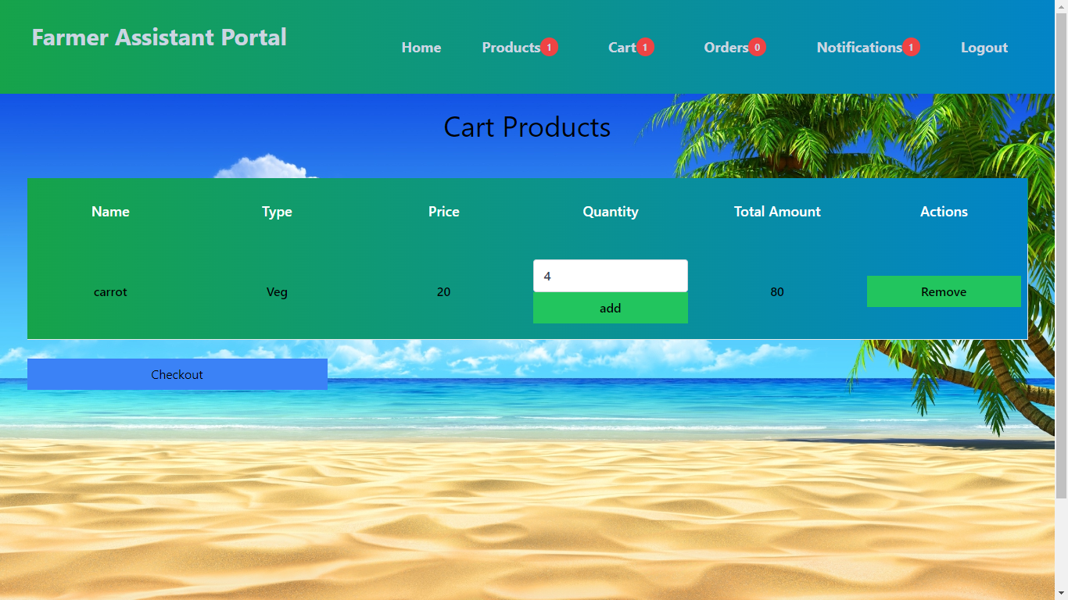

**View notifications:** Buyer can view all notifications

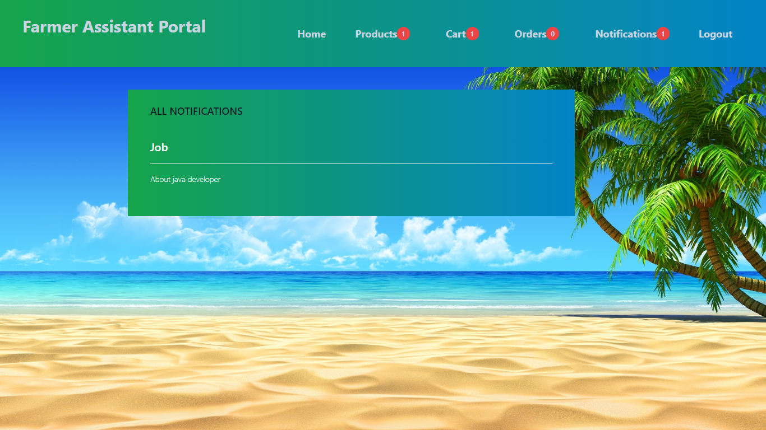

**SOFTWARE INSTALLATION FOR JAVA PROJECTS**

This Java Development Kit(JDK) allows you to code and run Java programs. It's possible that you install multiple JDK versions on the same PC. But It’s recommended that you install only latest version.

## How to install Java for Windows

Following are the steps for JDK 8 free download for 32 bit or JDK 8 download 64 bit and installation

**Step 1)** Go to [link](https://www.oracle.com/java/technologies/javase-downloads.html). Click on JDK Download for Java

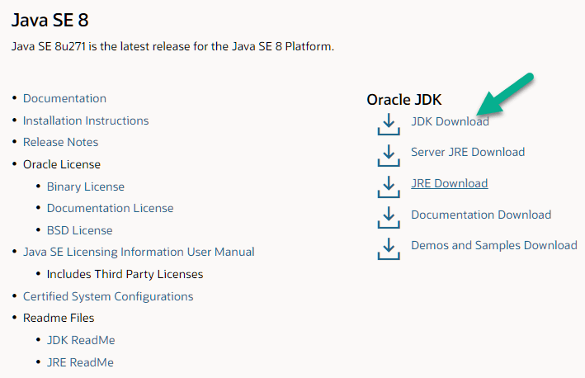

**Step 2)** Next,

1. Accept License Agreement
2. Download Java 8 JDK for your version 32 bit or JDK 8 download for windows 10 64 bit.

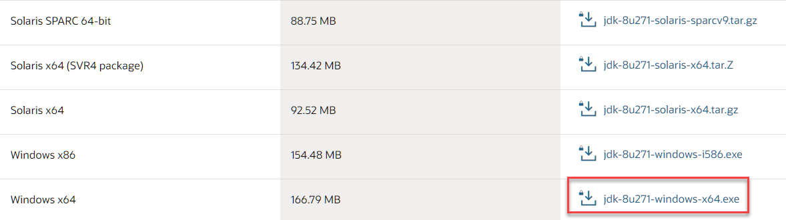

**Step 3)** when you click on the Installation link the popup will be open. Click on I reviewed and accept the Oracle Technology Network License Agreement for Oracle Java SE and you will be redirected to the login page. If you don't have an oracle account you can easily sign up by adding basics details of yours.

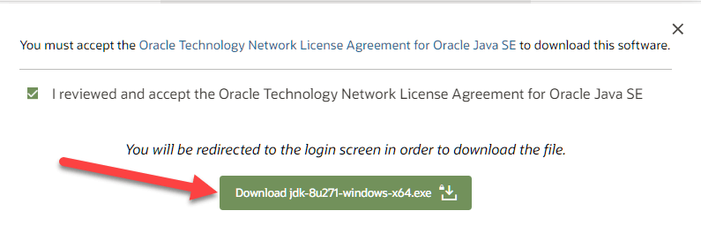

**Step 4)** Once the Java JDK 8 download is complete, run the exe for install JDK. Click Next

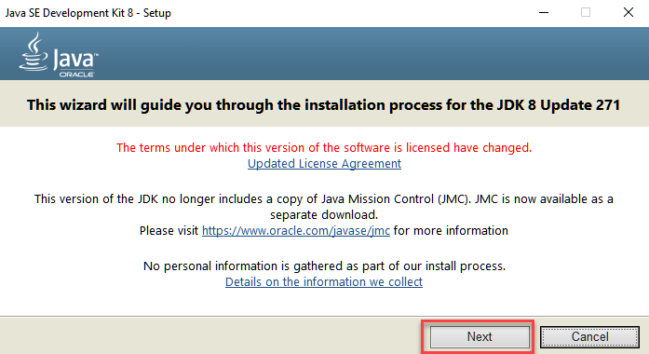

**Step 5)** Select the PATH to install Java in Windows and click next.

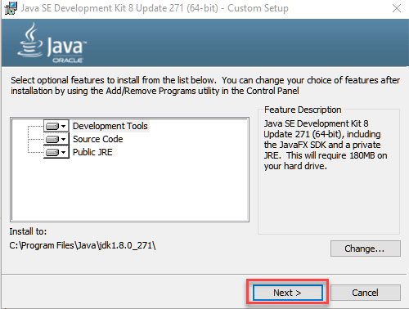

**Step 6)** Once you install Java in windows, click close

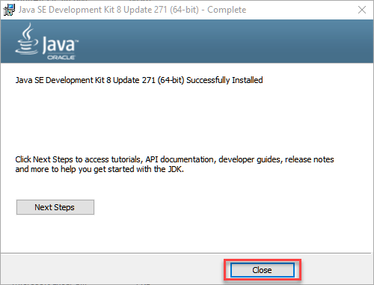

## How to set Environment Variables in Java: Path and Class path

The PATH variable gives the location of executable like javac, java etc. It is possible to run a program without specifying the PATH but you will need to give full path of executable like **C:\Program Files\Java\jdk-13.0.1\bin\javac A.java** instead of simple **javac A.java**

The CLASSPATH variable gives location of the Library Files.

Let's look into the steps to set the PATH and CLASSPATH

**Step 1)** Right Click on the My Computer and Select the properties



**Step 2)** Click on advanced system settings

**Step 3)** Click on Environment Variables

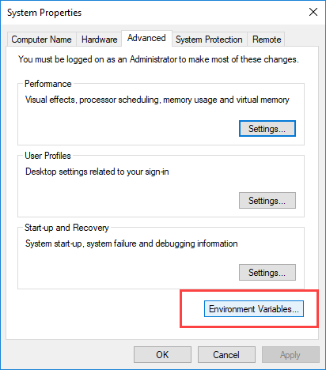

**Step 4)** Click on new Button of User variables

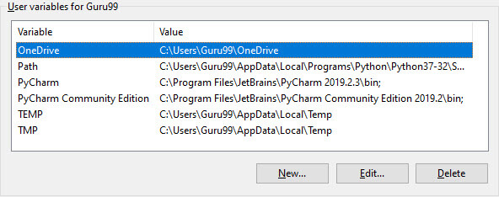

**Step 5)** Type PATH in the Variable name.

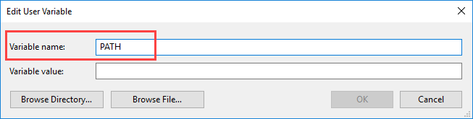

**Step 6)** Copy the path of bin folder which is installed in JDK folder.

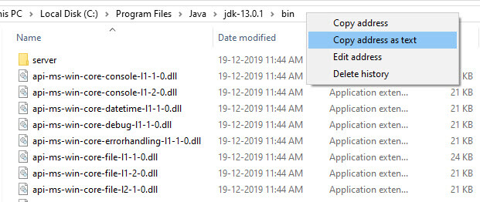

**Step 7)** Paste Path of bin folder in Variable value and click on OK Button.

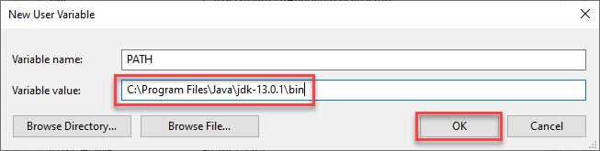

**Note:** In case you already have a PATH variable created in your PC, edit the PATH variable to

PATH = <JDK installation directory>\bin;%PATH%;

Here, %PATH% appends the existing path variable to our new value

**Step 8)**You can follow a similar process to set CLASSPATH.

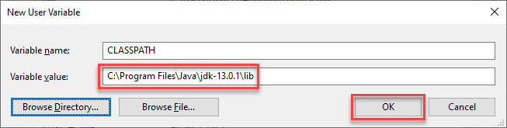

**Note:** In case you java installation does not work after installation, change classpath to

CLASSPATH = <JDK installation directory>\lib\tools.jar;

**Step 9)** Click on OK button

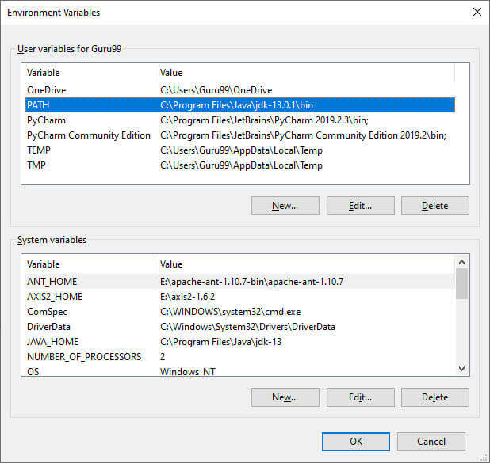

**Step 10)** Go to command prompt and type javac commands.

If you see a screen like below, Java is installed.

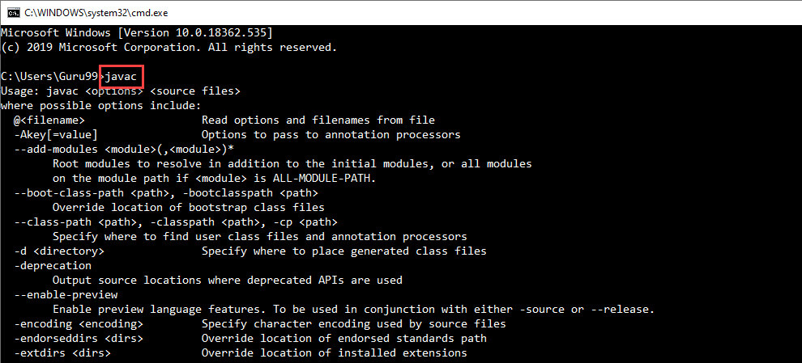

**INSTALLING JAVA AND INTELLIJ IDEA**

**Installing java:**

This Java Development Kit(JDK) allows you to code and run Java programs. It's possible that you install multiple JDK versions on the same PC. But It’s recommended that you install only latest version.

## How to install Java for Windows

Following are the steps for JDK 8 free download for 32 bit or JDK 8 download 64 bit and installation

**Step 1)** Go to [link](https://www.oracle.com/java/technologies/javase-downloads.html). Click on JDK Download for Java



**Step 2)** Next,

1. Accept License Agreement
2. Download Java 8 JDK for your version 32 bit or JDK 8 download for windows 10 64 bit.



**Step 3)** when you click on the Installation link the popup will be open. Click on I reviewed and accept the Oracle Technology Network License Agreement for Oracle Java SE and you will be redirected to the login page. If you don't have an oracle account you can easily sign up by adding basics details of yours.



**Step 4)** once the Java JDK 8 download is complete, run the exe for install JDK. Click Next



**Step 5)** Select the PATH to install Java in Windows and click next.



**Step 6)** Once you install Java in windows, click close



## How to set Environment Variables in Java: Path and Class path

The PATH variable gives the location of executable like javac, java etc. It is possible to run a program without specifying the PATH but you will need to give full path of executable like **C:\Program Files\Java\jdk-13.0.1\bin\javac A.java** instead of simple **javac A.java**

The CLASSPATH variable gives location of the Library Files.

Let's look into the steps to set the PATH and CLASSPATH

**Step 1)** Right Click on the My Computer and Select the properties



**Step 2)** Click on advanced system settings

**Step 3)** Click on Environment Variables



**Step 4)** Click on new Button of User variables



**Step 5)** Type PATH in the Variable name.



**Step 6)** Copy the path of bin folder which is installed in JDK folder.



**Step 7)** Paste Path of bin folder in Variable value and click on OK Button.



**Note:** In case you already have a PATH variable created in your PC, edit the PATH variable to

PATH = <JDK installation directory>\bin;%PATH%;

Here, %PATH% appends the existing path variable to our new value

**Step 8)**You can follow a similar process to set CLASSPATH.



**Note:** In case you java installation does not work after installation, change classpath to

CLASSPATH = <JDK installation directory>\lib\tools.jar;

**Step 9)** Click on OK button



**Step 10)** Go to command prompt and type javas commands.

If you see a screen like below, Java is installed.



Installing intellij idea:

1. To download Intellij visit the website https://www.jetbrains.com/idea/download/#section=windows and Click the "DOWNLOAD" link under the Community Section.

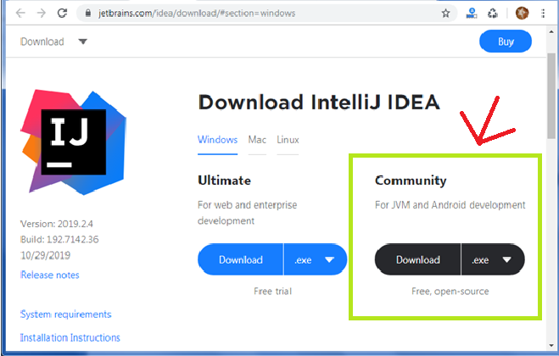

1. Once the download is complete, run the exe for install Intellij. The setup wizard should have started. Click “Next”.
2. On the next screen, Change the installation path if required. Click “Next”.
3. On the next screen, you can create a desktop shortcut if you want and click on “Next”.
4. Choose the start menu folder. Keep selected Jet Brains and click on “Install”.
5. Wait for the installation to finish.
6. Once installation finished, you should receive a message screen that Intellij is installed. If you want to go ahead and run it, click the “Run Intellij Community Edition” box first and click “Finish”.
7. After you click on "Finish," the Following screen will appear.

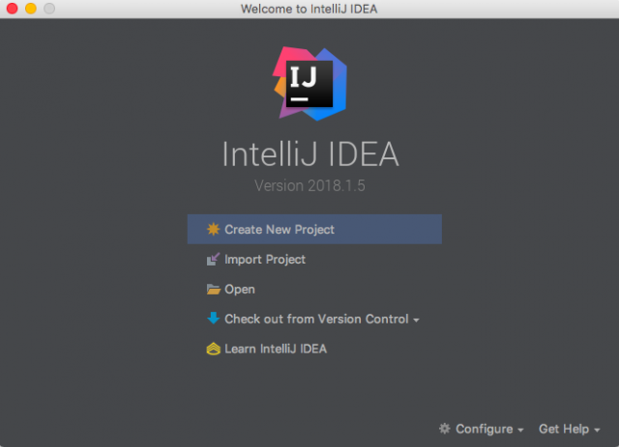

**Installing visual studio code**

Steps to installing visual studio code:

Step 1: Head over to the website <https://code.visualstudio.com/download>

Step2:choose the option as per your choice.

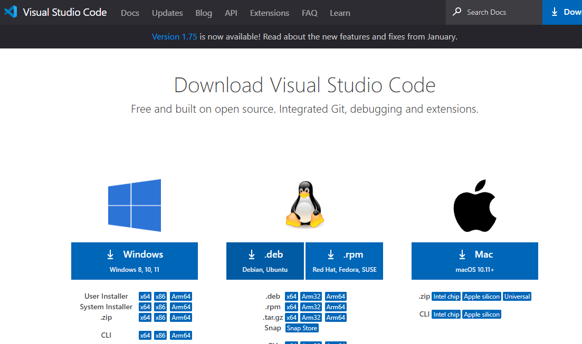

Step 3: Once download completed,open it and your screen will appear like this

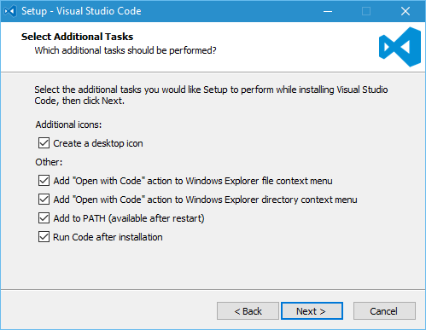

Step 4: click next until you saw the below page

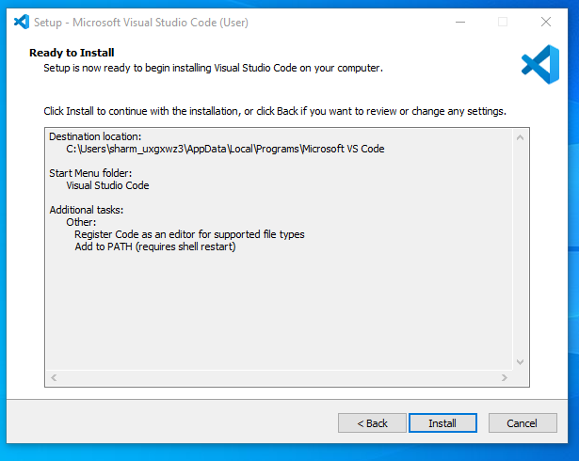

Step 4: After installation your screen will appear like this ,click finish and continue.

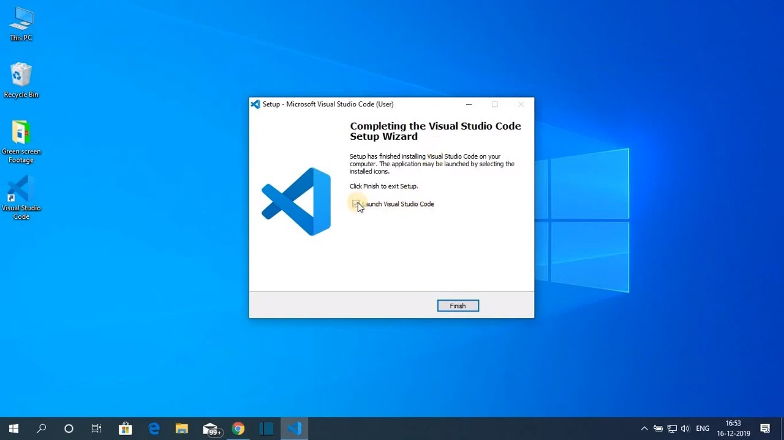

**Installing MongoDB**

**Step 1)**Download MongoDB Community Server

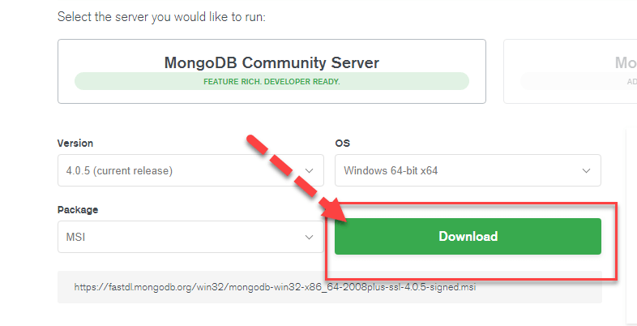

**Step 2)** Click on Setup

Once download is complete open the msi file. Click Next in the start up screen

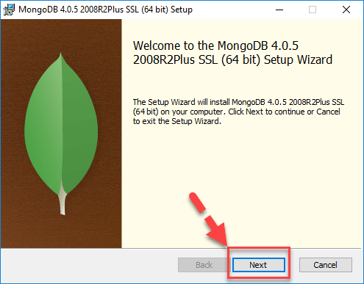

**Step 3)** Accept the End-User License Agreement

1. Accept the End-User License Agreement
2. Click Next

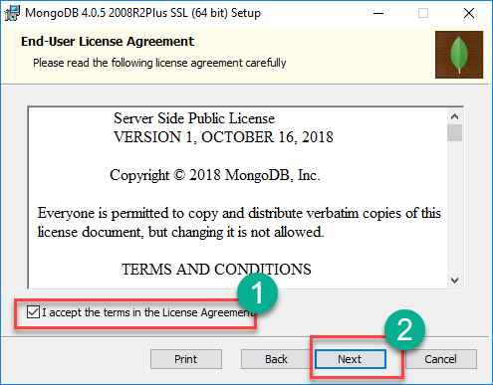

**Step 4)** Click on the “complete” button

Click on the “complete” button to install all of the components. The custom option can be used to install selective components or if you want to change the location of the installation.

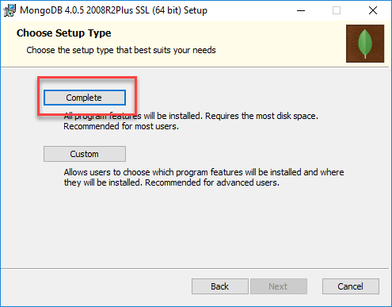

**Step 5)** Service Configuration

1. Select “Run service as Network Service user”. make a note of the data directory, we’ll need this later.
2. Click Next

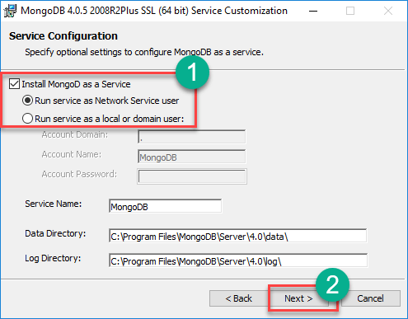

**Step 6)** Start installation process

Click on the Install button to start the installation.

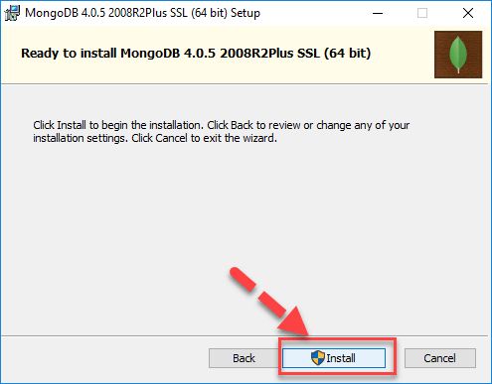

**Step 7)** Click Next once completed

Installation begins. Click Next once completed

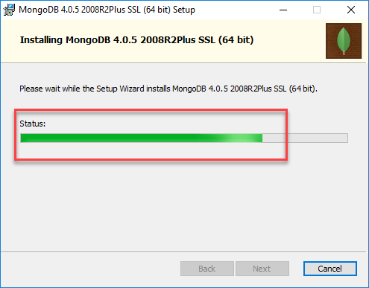

**Step 8)** Click on the Finish button

Final step, Once complete the installation, Click on the Finish button

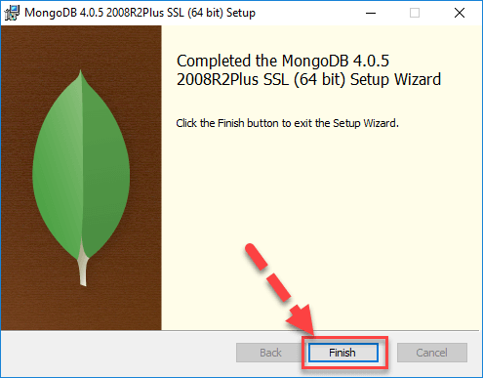

Step 16:click on finish.

**8. SYSTEM STUDY AND TESTING**

**8.1 Feasibility Study**

The feasibility of the project is analysed in this phase and business proposal is put forth with a very general plan for the project and some cost estimates. During system analysis the feasibility study of the proposed system is to be carried out. This is to ensure that the proposed system is not a burden to the company. For feasibility analysis, some understanding of the major requirements for the system is essential.

Three key considerations involved in the feasibility analysis are

* Economical feasibility
* Technical feasibility
* Social feasibility

**Economical Feasibility**

This study is carried out to check the economic impact that the system will have on the organization. The amount of fund that the company can pour into the research and development of the system is limited. The expenditures must be justified. Thus the developed system as well within the budget and this was achieved because most of the technologies used are freely available. Only the customized products had to be purchased.

### **Technical Feasibility**

This study is carried out to check the technical feasibility, that is, the technical requirements of the system. Any system developed must not have a high demand on the available technical resources. This will lead to high demands on the available technical resources. This will lead to high demands being placed on the client. The developed system must have a modest requirement, as only minimal or null changes are required for implementing this system.

**Social Feasibility**

The aspect of study is to check the level of acceptance of the system by the user. This includes the process of training the user to use the system efficiently. The user must not feel threatened by the system, instead must accept it as a necessity. The level of acceptance by the users solely depends on the methods that are employed to educate the user about the system and to make him familiar with it. His level of confidence must be raised so that he is also able to make some constructive criticism, which is welcomed, as he is the final user of the system.

### **System Testing**

The purpose of testing is to discover errors. Testing is the process of trying to discover every conceivable fault or weakness in a work product. It provides a way to check the functionality of components, sub-assemblies, assemblies and/or a finished product It is the process of exercising software with the intent of ensuring that the

Software system meets its requirements and user expectations and does not fail in an unacceptable manner. There are various types of test. Each test type addresses a specific testing requirement.

**8.2 Types of Tests**

**8.2.1 Unit testing**

Unit testing involves the design of test cases that validate that the internal program logic is functioning properly, and that program inputs produce valid outputs. All decision branches and internal code flow should be validated. It is the testing of individual software units of the application .it is done after the completion of an individual unit before integration. This is a structural testing, that relies on knowledge of its construction and is invasive. Unit tests perform basic tests at component level and test a specific business process, application, and/or system configuration. Unit tests ensure that each unique path of a business process performs accurately to the documented specifications and contains clearly defined inputs and expected results.

**8.2.2 Integration testing**

Integration tests are designed to test integrated software components to determine if they actually run as one program. Testing is event driven and is more concerned with the basic outcome of screens or fields. Integration tests demonstrate that although the components were individually satisfaction, as shown by successfully unit testing, the combination of components is correct and consistent. Integration testing is specifically aimed at exposing the problems that arise from the combination of components.

Software integration testing is the incremental integration testing of two or more integrated software components on a single platform to produce failures caused by interface defects.

The task of the integration test is to check that components or software applications, e.g. components in a software system or – one step up – software applications at the company level – interact without error.

**Test Results:** All the test cases mentioned above passed successfully. No defects encountered.

**Acceptance Testing**

User Acceptance Testing is a critical phase of any project and requires significant participation by the end user. It also ensures that the system meets the functional requirements.

**Test Results:** All the test cases mentioned above passed successfully. No defects encountered.

**8.2.3 Functional testing**

Functional tests provide systematic demonstrations that functions tested are available as specified by the business and technical requirements, system documentation, and user manuals.

Functional testing is centered on the following items:

Valid Input : identified classes of valid input must be accepted.

Invalid Input : identified classes of invalid input must be rejected.

Functions : identified functions must be exercised.

Output : identified classes of application outputs must be exercised.

Systems/Procedures: interfacing systems or procedures must be invoked.

Organization and preparation of functional tests is focused on requirements, key functions, or special test cases. In addition, systematic coverage pertaining to identify Business process flows; data fields, predefined processes, and successive processes must be considered for testing. Before functional testing is complete, additional tests are identified and the effective value of current tests is determined.

**9.2.4 White Box Testing**

White Box Testing is a testing in which in which the software tester has knowledge of the inner workings, structure and language of the software, or at least its purpose. It is purpose. It is used to test areas that cannot be reached from a black box level.

**9.2.5 Black Box Testing**

Black Box Testing is testing the software without any knowledge of the inner workings, structure or language of the module being tested. Black box tests, as most other kinds of tests, must be written from a definitive source document, such as specification or requirements document, such as specification or requirements document. It is a testing in which the software under test is treated, as a black box .you cannot “see” into it. The test provides inputs and responds to outputs without considering how the software works.

**Test objectives**

* All field entries must work properly.
* Pages must be activated from the identified link.
* The entry screen, messages and responses must not be delayed.

**Features to be tested**

* Verify that the entries are of the correct format
* No duplicate entries should be allowed
* All links should take the user to the correct page.

1. **FUTURE ENHANCEMENT**

In order to suggest future enhancements for a farmer assistant portal, it's important to consider the evolving needs of farmers, advancements in technology, and the broader trends in agriculture. Here are some potential enhancements for a farmer assistant portal:

Precision Agriculture Integration: Incorporate precision agriculture technologies like GPS, sensors, and drones to provide real-time data on soil health, moisture levels, and crop growth. This data can help farmers make informed decisions about irrigation, fertilization, and pest control.

Crop Disease and Pest Detection: Implement image recognition and AI algorithms to identify crop diseases and pests early. Provide recommendations for appropriate treatments, minimizing crop losses and reducing the need for excessive pesticide use.

Weather Forecast Integration: Integrate accurate weather forecasts into the portal to help farmers plan their activities more effectively. This can include alerts for extreme weather events and tailored advice for each farmer's location and crops.

Marketplace Integration: Create a marketplace feature where farmers can directly connect with buyers, processors, and distributors. This could streamline the process of selling crops and products, enabling farmers to get fair prices and reducing middlemen.

Financial Management Tools: Provide tools for budgeting, expense tracking, and revenue forecasting. This can help farmers manage their finances more efficiently and plan for future investments.

Customized Recommendations: Use machine learning algorithms to analyze data from each farmer's operation and provide personalized recommendations for crop selection, planting times, and cultivation practices.

Resource Sharing and Community Building: Include features that allow farmers to share their experiences, best practices, and challenges with each other. This could foster a sense of community and enable knowledge exchange.

Remote Consultation: Offer a feature where farmers can connect with agricultural experts and agronomists through video calls or chat for real-time advice on issues they encounter.

Training and Educational Content: Develop a section with tutorials, webinars, and educational content to help farmers stay updated on the latest agricultural techniques, technologies, and regulations.

Sustainability Insights: Provide information and tools to promote sustainable farming practices, such as water conservation, soil health improvement, and biodiversity preservation.

Government Policy Updates: Keep farmers informed about changes in agricultural policies, subsidies, and regulations that may impact their operations.

Data Privacy and Security: Ensure that the portal complies with data privacy regulations and incorporates robust security measures to protect sensitive information.

Mobile App: Create a companion mobile app for the portal to provide on-the-go access to important information and tools.

Integration with IoT Devices: Allow farmers to connect their IoT devices (such as soil moisture sensors or automated irrigation systems) to the portal, enabling centralized monitoring and control.

Predictive Analytics: Use historical data and predictive analytics to help farmers anticipate challenges like crop diseases, yield fluctuations, or market price changes.

Remember, the key to successful enhancements is to continually gather feedback from farmers, incorporate user-centered design principles, and stay abreast of technological advancements in the agriculture sector. This will ensure that the farmer assistant portal remains a valuable and relevant tool for agricultural professionals.

**10. CONCLUSION**

The Farmer Assistant Portal stands as a promising and essential tool that bridges the gap between traditional farming practices and the advancements of the digital age. By combining technology, data analytics, and agricultural expertise, the portal empowers farmers to make informed decisions, optimize their operations, and adapt to the evolving challenges of modern agriculture.

**11.REFERANCES**

International Journal of Advanced Science and Technology

Vol. 29, No. 6, (2020), pp. 4783 - 4786

[1] Manav Singhal, Kshitij Verma, Anupam Shukla, “Krishi Ville-Android based solution for Indian agriculture”. 2011 Fifth IEEE International Conference on Advanced Telecommunication Systems and Networks (ANTS), 18-21 Dec. 2011, Bangalore, India.

[2] Soumalya Ghosh, A. B. Garg, Sayan Sarcar, P.S.V.S Sridhar, Ojasvi Maleyvar, and Raveesh kapoor, “Krishi-Bharati: An Interface for Indian Farmer”, Proceedings of the 2014 IEEE Students' Technology Symposium, 28 Feb.-2 March 2014, Kharagpur, India.

[3] Shankar M. Patil, Monika Jadhav, Vishakha Jagtap, “Android Application for Farmers”, International Research Journal of Engineering and Technology, volume 6, issue 4, 2019, 4200-4202p.

[4] Shital Chaudhari, Vaishnavi Mhatre, Pooja Patil, Sandeep Chavan, “Smart Farm Application: A Modern Farming Technique Using Android Application”, International Research Journal of Engineering and Technology, volume 5, issue 2, 2018, 318-320p.

[5] Arpit Narechania “KisanVikas – Android Based ICT Solution in Indian Agriculture to Assist Farmers”. Proceeding of the 7th International Conference on Information and Communication Technologies in Agriculture, Food and Environment (HAICTA 2015), Kavala, Greece, 17-20 September, 2015.

[6] Shaik. N. Meera, Anita Jhamtani, D.U.M. Rao (2004). Information and Communication Technology in Agricultural Development: A Comparative Analysis of Three Projects from India [Online] Available from: https://www.odi.org/sites/odi.org.uk/files/odi-assets/publications-opinion-files/5186.pdf [April 2020].

[7] Agro Products (2020). Origin of Agriculture. [Online] Available from:

http://www.agriculturalproductsindia.com/agro/history.html [Accessed April 2020].

[8] ICT in Agriculture (2020). National Round Table Conference. [Online] Available from: https://www.icfa.org.in/assets/doc/reports/ICT_in_Agriculture.pdf [Accessed April 2020].

[9] L. N. De Silva, J. S. Goonetillake, G. N. Wikramanayake, and A. Ginige, “Towards using ICT to enhance flow of information to aid farmer sustainability in Sri Lanka,” 23rd Australasian Conference on Information Systems, 3-5 Dec 2012, Geelong.

[10] Punchihewa, Devaka J., and Prasad Wimalaratne. "Towards an ICT Enabled Farming Community." [Online] Available from: <https://www.aesanetwork.org/wp-content/uploads/2018/02/0000Towards-an-> ICT-Enabled-Farming-Community.pdf [Accessed April 2020].